A

PROJECT REPORT

ON

COMMERCIENT SYNC

Submitted by

Prajapati Nirmal Hasmukhbhai (ET22MTCA104)

**Under the Guidance Of**

Prof. Zankhana Vaishnav

In fulfillment of the award of the degree

of

Master of Computer Applications

At



Sarvajanik College of Engineering & Technology, Surat

Sarvajanik University, Surat

May 2024

|  |  |  |
| --- | --- | --- |
|  | **SARVAJANIK UNIVERSITY**  **Sarvajanik College of Engineering and Technology**  **MASTER OF COMPUTER APPLICATIONS**  **Academic Year 2023-24** | SCET and SES logo |

Date: 27-04-2024

CERTIFICATE

This is to certify that the project entitled “COMMERCIENT SYNC” has been   
Submitted by PRAJAPATI NIRMAL HASMUKHBHAI (ET22MTCA104) towards the fulfillment of the degree of Master of Computer Applications (M.C.A.) in (4th Semester) of Sarvajanik University, Surat during the academic year 2023-24.

|  |  |
| --- | --- |
| Guide Name: Prof. Zankhana Vaishnav |  |
|  | **(Prof. Gayatri Kapadia**  **Head - M.C.A. Department)** |
| **(Guide’s Signature)** |

|  |  |  |  |
| --- | --- | --- | --- |
| Examiners’ Signature:  1.__________________________ |  |  |  |
| **2.__________________________** |  |  |  |
| **3.**__________________________ |  |  |  |

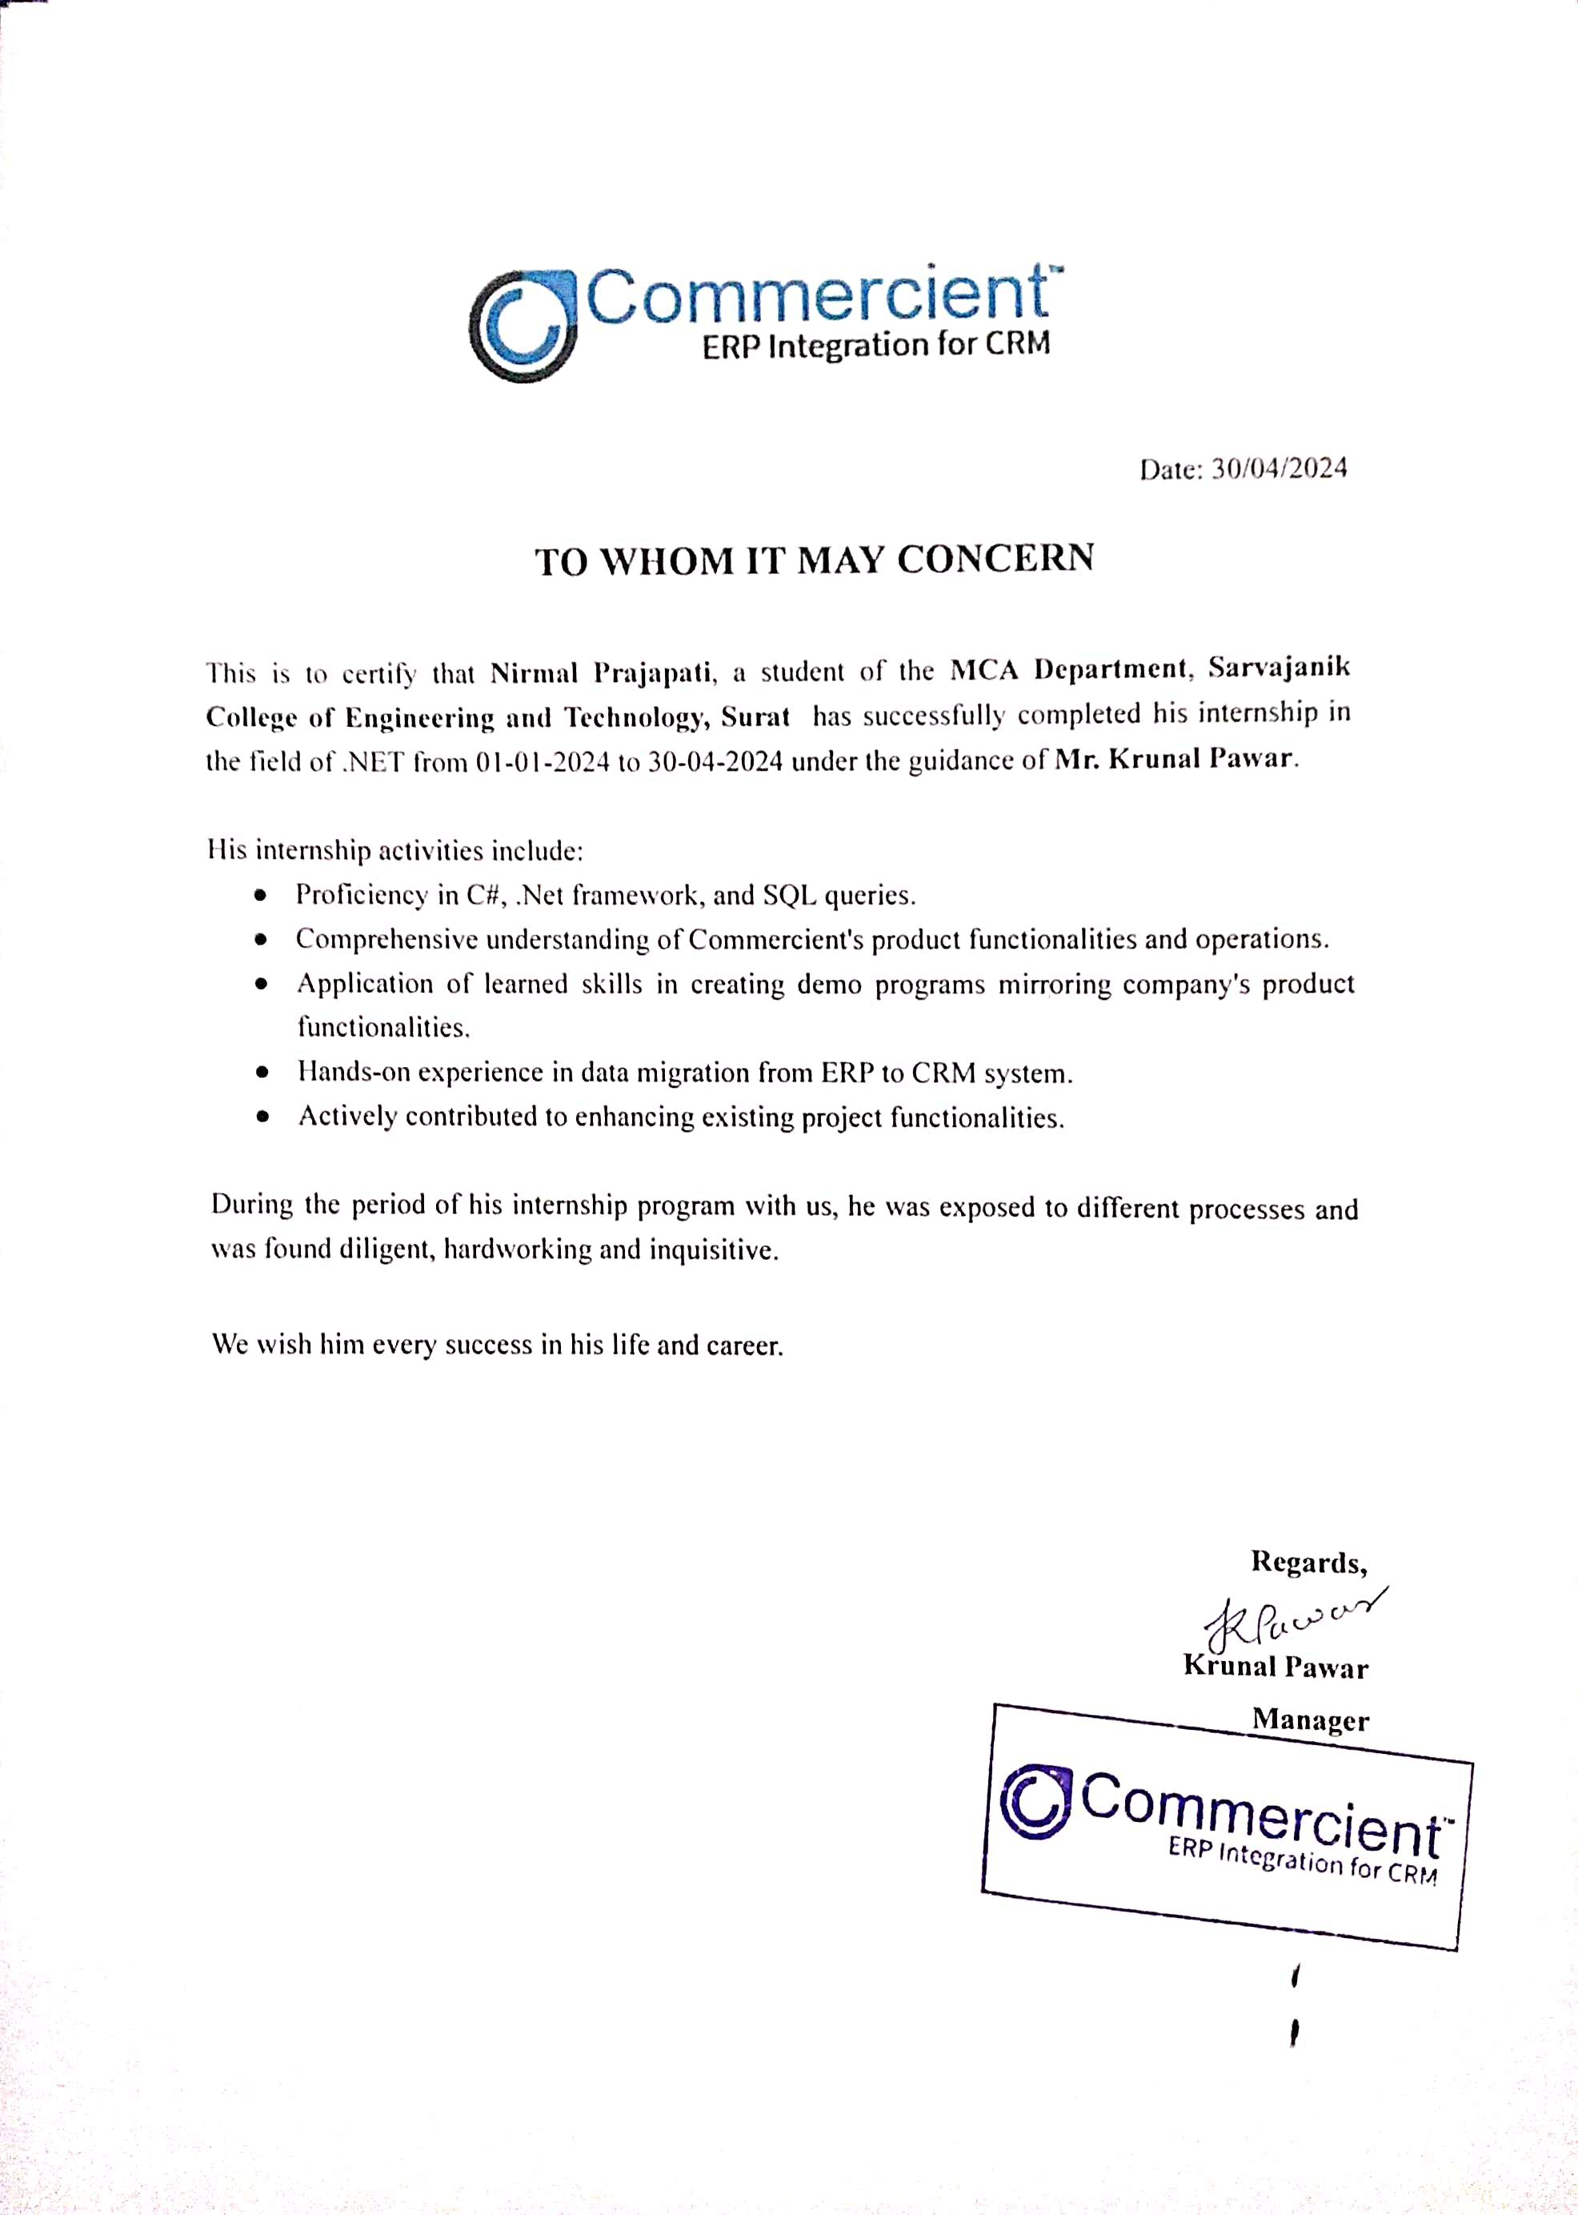

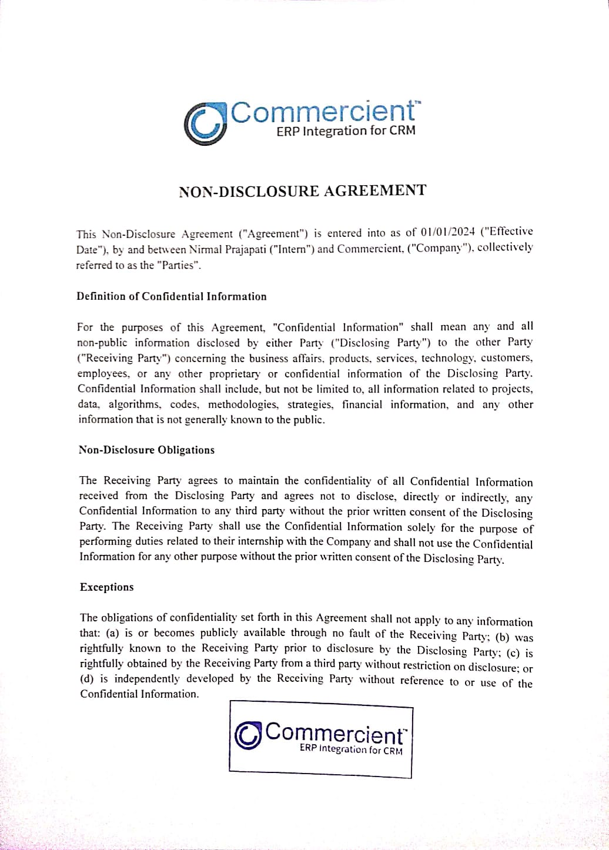

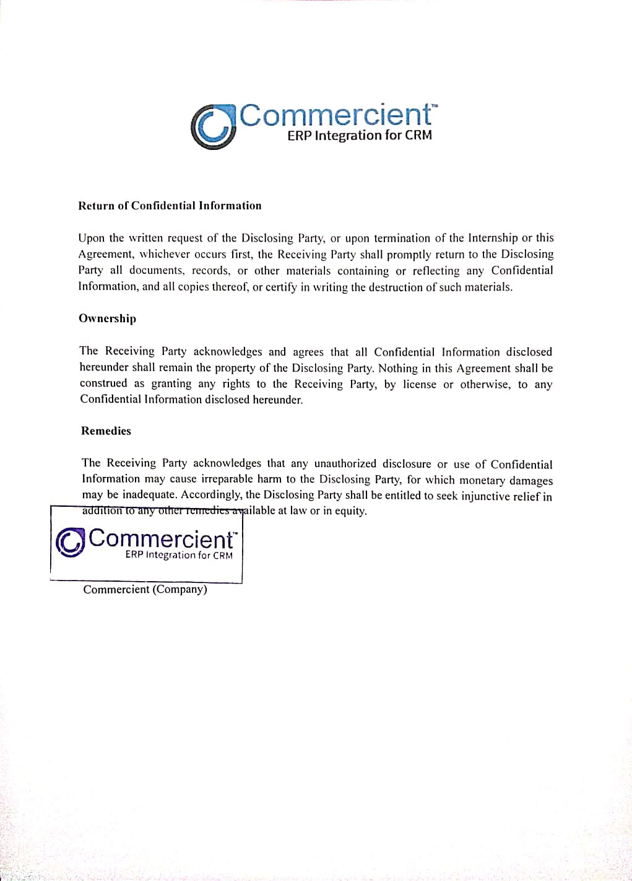

**Self-Declaration**

**Title of the Project: Commercient SYNC**

|  |  |
| --- | --- |
| **Enrolment Number** | **Student Name** |
| ET22MTCA104 | Prajapati Nirmal Hasmukhbhai |

I, hereby declare that the above-mentioned project report submitted by me has been prepared by me and is original in its content and it has not been submitted anywhere else. I confirm that the report is only prepared for academic requirements, not for any other purpose. It might not be used by anyone for any other purpose.

**Acknowledgment**

I express my sense of pleasure towards the Training Officer of Commercient LLC, who gave me a chance to do the project work. He always motivates me and provides extraordinary infrastructure and resources to work. Moreover, I learned the lesson of "commitment to work" from him. I remember him for his cordial and gentle nature.

I express my deep sense of gratitude and indebtedness to my guide, Mr. Krunal Pawar, for accepting me to work under his training and supervision. He took a prolonged interest in my work and directed me toward the predefined goal. He has shown me a way to pursue excellence. He witnessed my work every time and helped a lot. He has been a big factor of motivation in my project.

I sincerely thank Prof. Zankhana Vaishnav, MCA department, who provided me with constant motivation for knowledge acquisition and moral support during project work.

I would once again like to express my heartiest gratitude to my family and friends who have always guided me toward the path of success and helped to make this project work successfully.

From,

Nirmal Prajapati

**Index**

|  |  |  |
| --- | --- | --- |
| **Sr.No** | **Particular** | **Pg. No** |
| **1** | **Introduction** | 1 |
|  | 1.1 Existing System | 1 |
|  | 1.2 Need for the New System | 2 |
|  | 1.3 Objective of the New System | 2 |
|  | 1.4 Problem Definition | 2 |
|  | 1.5 Core Components | 3 |
|  | 1.6 Project Profile | 4 |
|  | 1.7 Assumptions and Constraints | 5 |
|  | 1.8 Advantages and Limitations of the Proposed System | 6 |
| **2** | **Requirement Determination & Analysis** | 7 |
|  | 2.1 Requirement Determination | 7 |
|  | 2.2 Targeted Users | 8 |
| **3** | **System Design** | 9 |
|  | 3.1 Use Case Diagram | 9 |
|  | 3.2 Interaction Diagram | 11 |
|  | 3.3 Activity Diagram | 13 |
| **4** | **Development** | 14 |
|  | 4.1 Coding Standards | 14 |
|  | 4.2 Screen Shots | 15 |
| **5** | **Agile Documentation** | 23 |
|  | 5.1 Agile Project Charter | 23 |
|  | 5.2 Agile Roadmap / Schedule | 24 |
|  | 5.3 Agile Project Plan | 25 |
|  | 5.4 Agile User Story (Minimum 3 Tasks) | 27 |
|  | 5.5 Agile Release Plan | 28 |
|  | 5.6 Agile Sprint Backlog | 30 |
|  | 5.7 Agile Test Plan | 31 |
| **6** | **Proposed Enhancements** | 32 |
| **7** | **Conclusion** | 33 |
| **8** | **Bibliography** | 34 |

1. **Introduction**

Commercient: Your Solution for Seamless Business Integration. In today's fast-paced business world, streamlining operations and maximizing efficiency are key to staying competitive. That's where Commercient comes in. With a mission to simplify ERP and CRM integration, Commercient offers a comprehensive solution designed to meet the needs of businesses of all sizes.

Imagine a world where your ERP and CRM systems work together seamlessly, without the headache of complex integrations. Commercient makes this a reality by providing an easy-to-use platform that allows you to connect your systems quickly and efficiently. Whether you're a small startup or a large enterprise, Commercient has the tools and expertise to help you integrate your systems with ease.

With a proven track record of assisting over 1000 global companies, Commercient understands the challenges businesses face when it comes to integration. That's why they've developed an "out of the box" solution that can be deployed rapidly, with minimal services and overhead costs. Say goodbye to long implementation times and costly integration projects – with Commercient, you can start seeing results faster than ever before.

But Commercient isn't just about making integration easy – it's about helping businesses thrive. By providing access to a wide range of ERP systems, including popular platforms like NetSuite and SAP, as well as specialized solutions for specific industries, Commercient ensures that businesses have the tools they need to succeed in today's competitive landscape.

* 1. **Existing System**

Before Commercient came along, connecting ERP and CRM systems was hard work for businesses. It took a long time to set up, cost a lot of money, and was very complicated. Companies often had trouble making different systems work together, and there weren't any easy solutions available. This meant that every integration project was unique and didn't always work well. As a result, businesses couldn't use their systems effectively, which made it harder for them to get things done efficiently.

* 1. **Need for the new System**
* **Easy Data Management**: Commercient helps businesses handle and track data easily.
* **Lots of Data**: Businesses have a lot of data, and Commercient helps them handle it well.
* **Need for Efficiency**: Modern businesses need tools like Commercient to work better.
* **Simplifying System Fusion**: Commercient makes it easier for businesses to merge their ERP and CRM systems, ensuring a smoother integration process.
  1. **Objective of the New System**
* **Better Performance and Productivity**: Commercient aims to help businesses perform better and get more done.
* **Monitoring Performance**: It helps keep track of how projects are doing in real-time.
* **Keeping Work Records**: Commercient helps keep track of what's been done and what's next.
* **Less Work**: It automates tasks to save time and effort.
* **Easy to Use**: Commercient is designed to be simple and easy for anyone to use.
* **Automated Task Management**: Utilizing AI technology, Commercient automates various tasks, reducing manual workload and freeing up time for more strategic activities.
  1. **Problem Definition**

Commercient tackles the issue of seamlessly integrating Enterprise Resource Planning (ERP) and Customer Relationship Management (CRM) systems. Businesses often face complex, costly integration processes, compatibility issues, and user interface challenges. Commercient simplifies this, making integration easier, faster, and more cost-effective, ultimately boosting efficiency and productivity.

* 1. **Core Components**

There are majorly three components where users or businesses can choose them according to their requirements. All of these components offer full functionalities accessible through Client, Admin Panels, and Support team resources.

1. **ERP to CRM Integration:**

* Allows users to integrate ERP data with CRM using a one-way SYNC app.
* Syncs ERP data to CRM, ensuring smooth transfer and accessibility.
* Enables managing ERP data within CRM, enhancing efficiency.

1. **CRM to ERP Integration:**

* Let’s users integrate CRM data with ERP using SYNC application.
* Facilitates CRM data export to ERP, ensuring seamless integration.
* Allows transferring CRM data to ERP for comprehensive access.

1. **ERP and CRM SYNC:**

* Offers a two-way SYNC app for integrating ERP and CRM data.
* Creates a master system by synchronizing data between ERP and CRM.
* Enables bidirectional data synchronization for real-time updates.
* Provides streamlined processes and enhanced data accuracy.
  1. **Project Profile**



|  |  |
| --- | --- |
|  |  |
| Project Title | Commercient SYNC |
| Developed By | Commercient LLC |
| Technology Used | C#, .NET Core, Python, AWS S3 Bucket,  Microsoft SQL Server |
| Project Mentor | Mr. Krunal Pawar |
| Team Size | One |
| Developers | Nirmal Prajapati |

* 1. **Assumptions and Constraints**

**Assumptions:**

* Assumes that the ERP and CRM systems targeted for integration are compatible with Commercient's integration solution.
* Assumes that users have access to a stable internet connection to facilitate data transfer and synchronization.
* Assumes that users have a basic understanding of ERP and CRM systems, as well as the operation of Commercient's integration platform.
* Assumes that the data input into the ERP and CRM systems is accurate and reliable for effective integration.

**Constraints:**

* Commercient's integration solution may have limitations in integrating with certain legacy or customized ERP and CRM systems.
* Users may face limitations in terms of available storage space, bandwidth, or computing resources, which could impact the efficiency of data synchronization.
* Integration of sensitive business data between ERP and CRM systems may pose security risks, requiring stringent data protection measures.
* Commercient's integration solution must comply with relevant data privacy regulations and industry standards to ensure legal and ethical data handling practices.
  1. **Advantages and Limitations of the Proposed System**

**Advantages**:

* Enhanced Data Visibility
* Improved Efficiency
* Seamless Communication
* Enhanced Customer Experience
* Better Analytics and Reporting

**Limitations**:

* Complexity and Cost
* Compatibility Issues
* Data Security Concerns
* Dependency on Vendor Support
* Change Management Challenges

1. **Requirement Determination & Analysis**
   1. **Requirement Determination**
2. **Functional Requirements**:

* **Data Synchronization**: The system should facilitate bidirectional synchronization of data between ERP and CRM systems, ensuring consistency and accuracy across both platforms.
* **Customer and Sales Order Integration**: Users should be able to synchronize customer information, sales orders, invoices, and payments between ERP and CRM systems seamlessly.
* **Product and Inventory Management**: The system should support the integration of product catalogs, inventory levels, and pricing information between ERP and CRM systems.
* **Opportunity and Lead Management**: Users should be able to synchronize opportunity and lead data between CRM and ERP systems, enabling sales teams to track prospects and opportunities effectively.
* **Quote and Order Management**: The system should enable the transfer of quotes and orders between CRM and ERP systems, facilitating efficient order processing and fulfillment.
* **Reporting and Analytics**: Users should have access to integrated reporting and analytics capabilities, powered by AI-driven insights and predictive analytics models, to generate comprehensive reports and actionable insights based on data from both ERP and CRM systems.

1. **Non-Functional Requirements**:

* **Security**: The integration should implement robust security measures to protect sensitive data during transmission and storage, ensuring compliance with data protection regulations.
* **Performance**: The integration should have optimal performance, with minimal latency and efficient data processing to support real-time synchronization between ERP and CRM systems.
* **Scalability**: The integration should be scalable to accommodate growing data volumes and user loads, allowing for seamless expansion without compromising performance.
* **Usability**: The integration should be user-friendly, with intuitive interfaces and clear navigation to facilitate ease of use for employees accessing data across ERP and CRM systems.
* **Reliability**: The integration should be reliable, with built-in error handling mechanisms and failover capabilities to ensure uninterrupted data synchronization and business continuity.
* **Compliance**: The integration should comply with relevant industry standards and regulations, such as GDPR, HIPAA, and SOC 2, to ensure data privacy, security, and regulatory compliance.
  1. **Targeted Users**

Commercient's target audience spans executives, sales reps, finance teams, customer service, IT admins, marketers, and operations managers relying on ERP and CRM systems. Commercient's integration solutions aim to simplify workflows by seamlessly connecting ERP and CRM systems, enabling efficient access and leveraging of integrated data. From executives seeking strategic insights to sales teams managing customers, Commercient empowers users to make informed decisions, boost productivity, and foster collaboration across the organization.

1. **System Diagram**
   1. **Use Case Diagram**

* **Use Case Diagram for User**

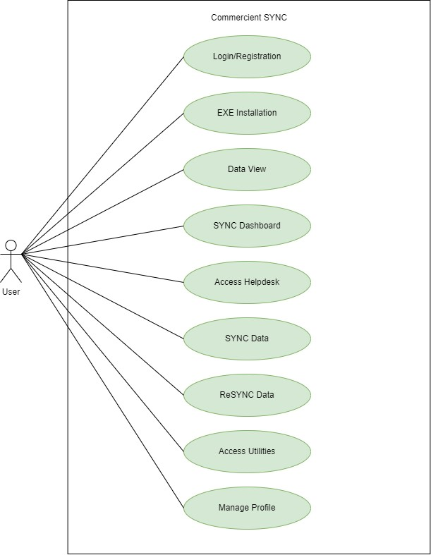

**Figure 3.1.1 Use Case Diagram for User**

* **Use Case Diagram for Admin**

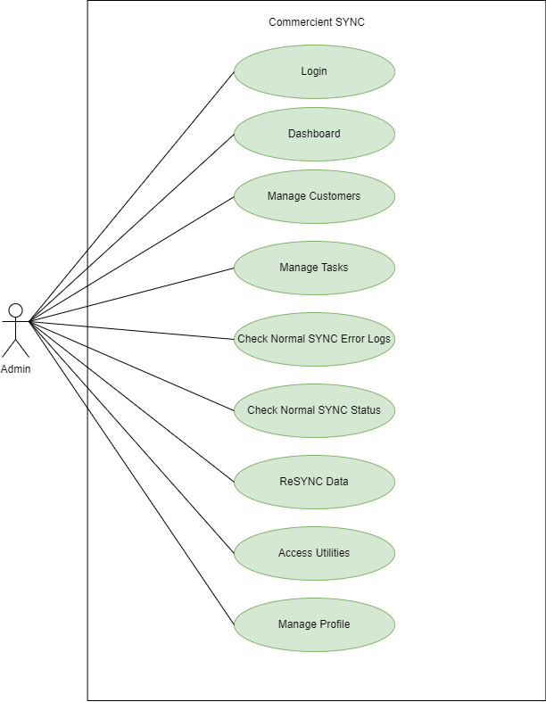

**Figure 3.1.2 Use Case Diagram for Admin**

* 1. **Interaction Diagram**
* **Interaction Diagram for Admin**

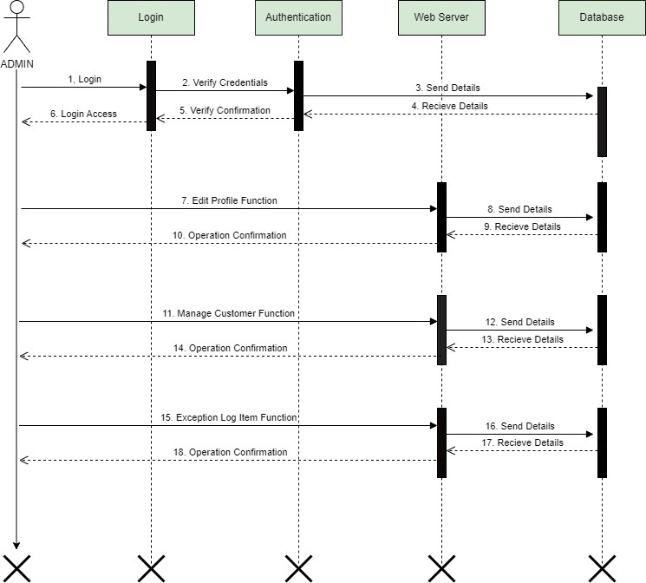

***Figure 3.2.1 Interaction Diagram for Admin***

* **Interaction Diagram for Customer**

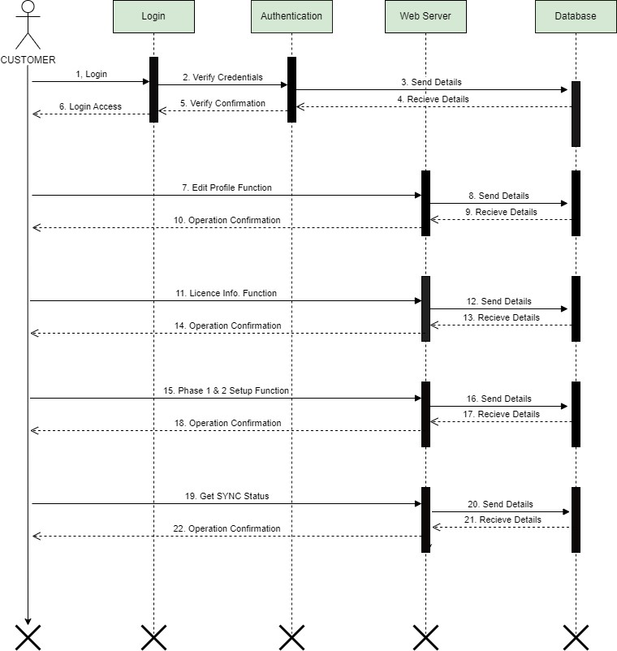

***Figure 3.2.2 Interaction Diagram for Customer***

* 1. **Activity Diagram**
* **Activity Diagram for Normal SYNC**

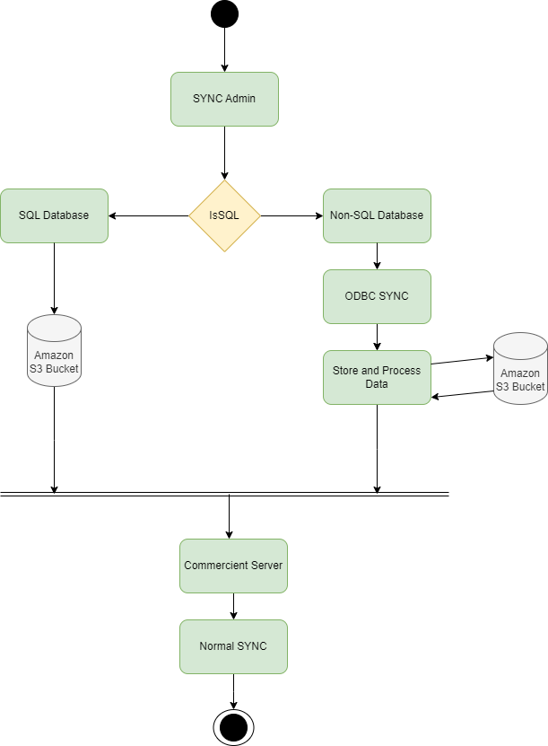

***Figure 3.3 Activity Diagram for Normal SYNC***

1. **Development**
   1. **Coding Standards**

General coding standards pertain to how the developer writes code. The Commercient has come up with a small set of items it feels should be followed regardless of the programming language being used.

* **Indentation**

Proper and consistent indentation is important in producing easy to read and maintainable programs. Indentation should be used to:

1. Emphasize the body of a control statement such as a loop or a select statement
2. Emphasize the body of a conditional statement
3. Emphasize a new scope block

* **Inline Comments**

Inline comments explaining the functioning of the subroutine or key aspects of the algorithm shall be frequently used.

* **Structured Programming**

Structured (or modular) programming techniques shall be used. GO TO statements shall not be used as they lead to “spaghetti” code, which is hard to read and maintain.

* **Error Handling with Logs**

Error handling should be implemented consistently throughout the codebase to ensure robustness and reliability. All critical errors and exceptions should be caught and logged appropriately. Logging should follow a standardized format and include relevant information such as timestamp, error message, severity level, and context. Additionally, log files should be regularly monitored and archived to facilitate troubleshooting and auditing.

* **Naming Conventions**

Prefixes or suffixes can be employed to distinguish between different types of variables or entities. For tables specifically, a consistent prefix such as "LogSF_ERP_Name_" for Customer Log Tables and “Commercient_" for Commercient Server Tables should be used.

* 1. **Screen Shots**

**4.2.1 Admin Login**

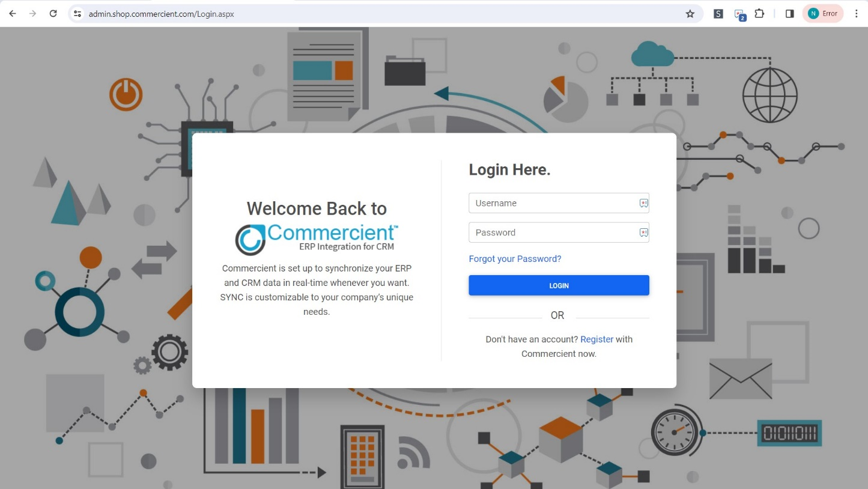

**4.2.2 Dashboard**

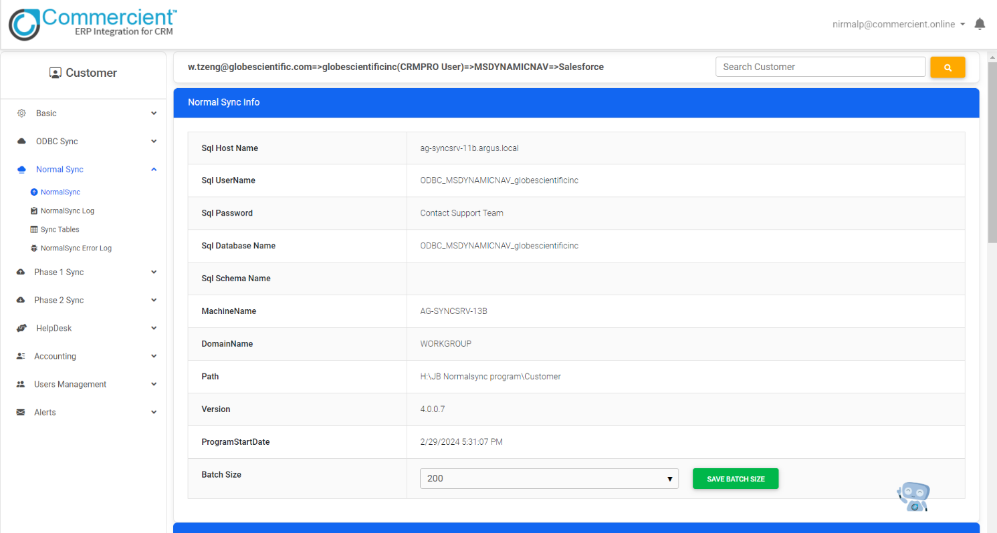

**4.2.3 Normal SYNC**



**4.2.4 Customer Data**

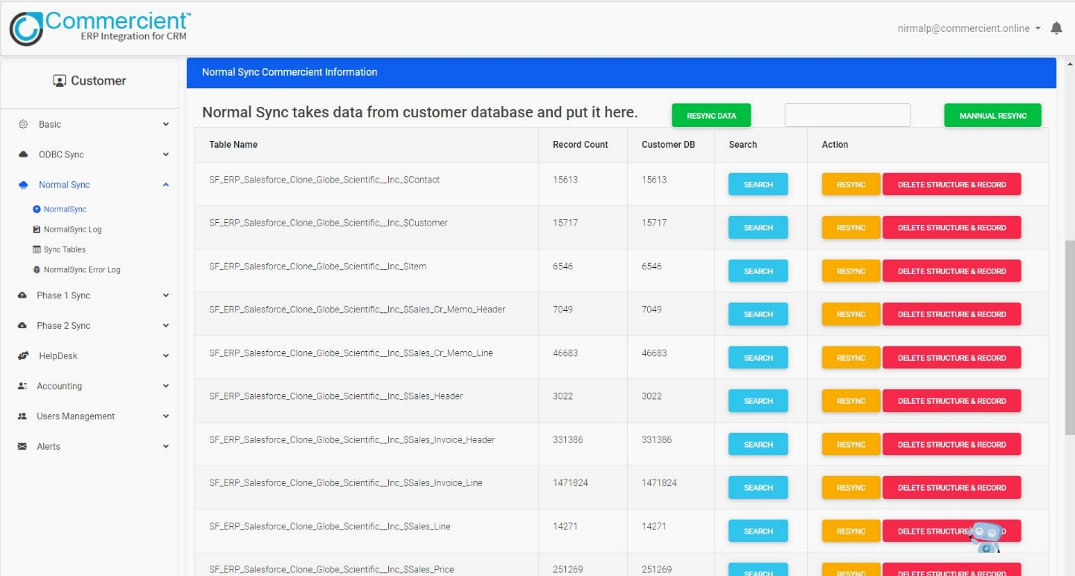

**4.2.5 Normal SYNC Logs**

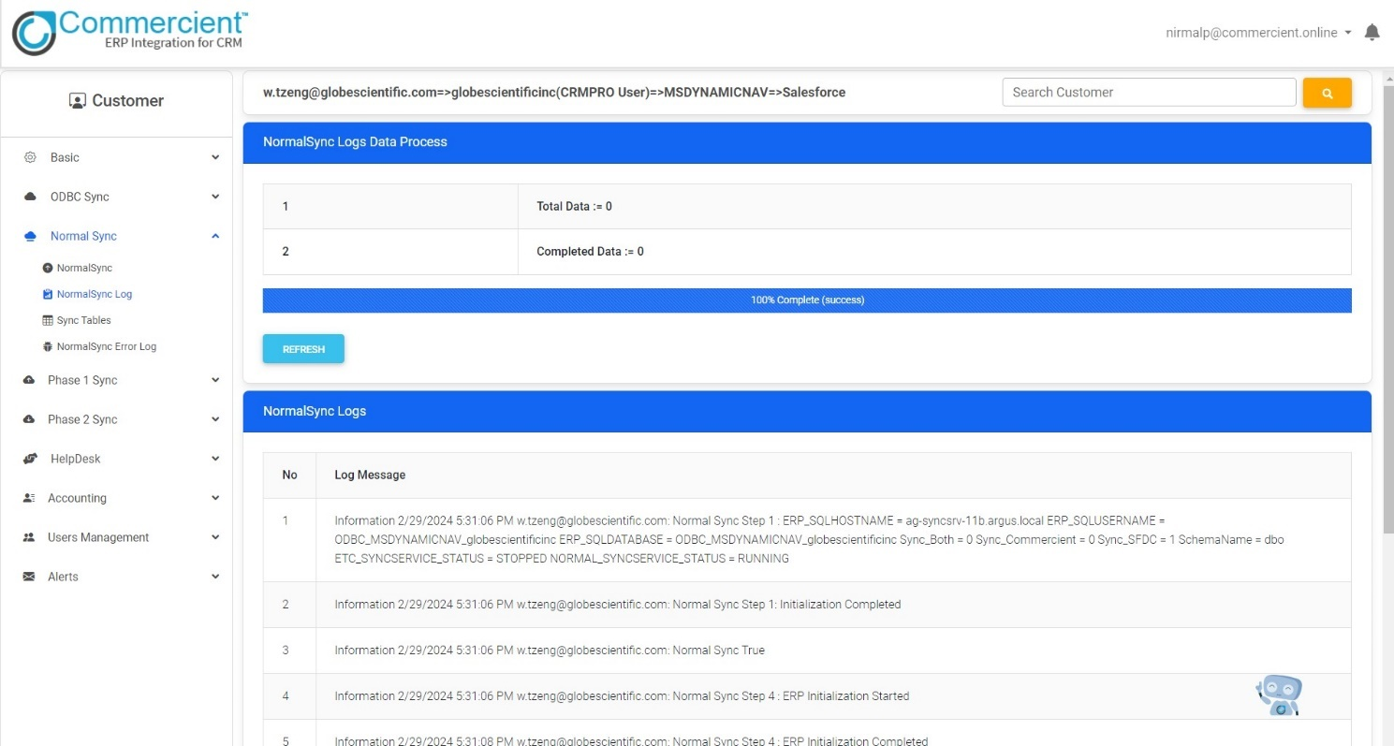

**4.2.6 Tasks Dashboard**

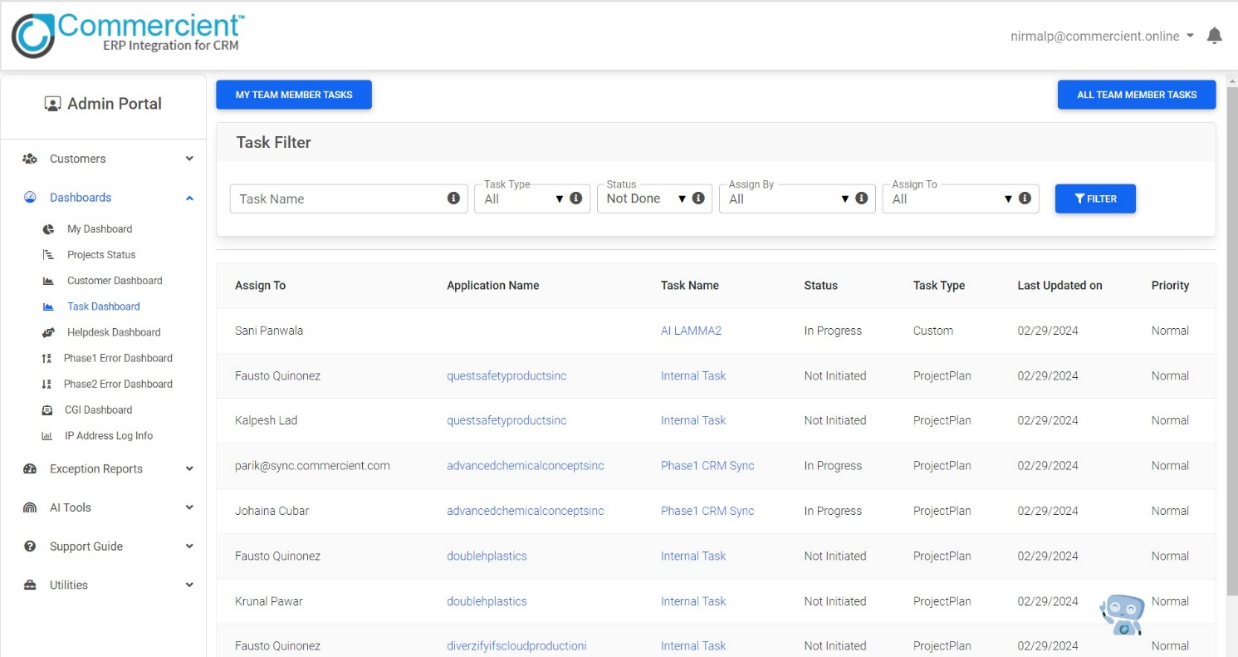

**4.2.7 Task Updates**

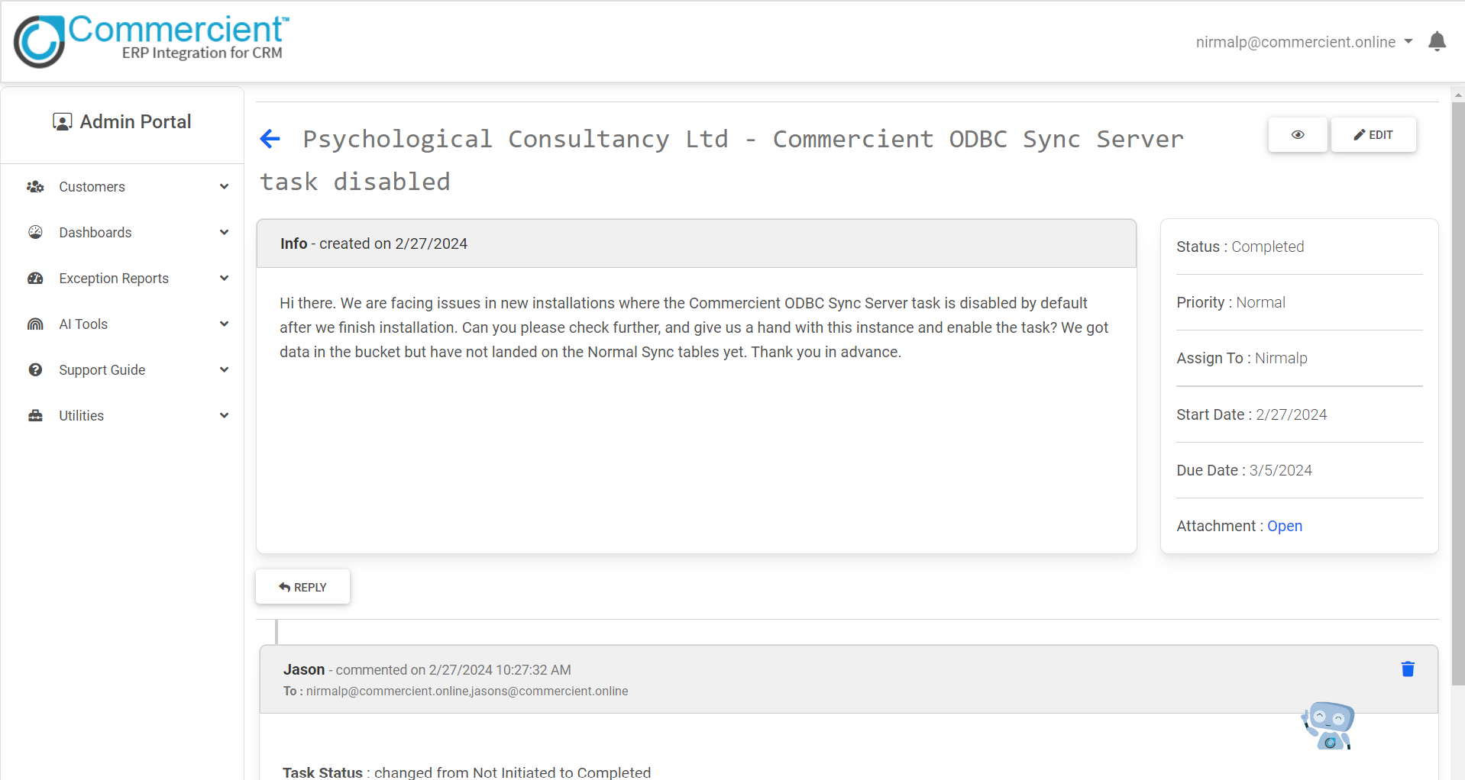**4.2.8 Sync Table**

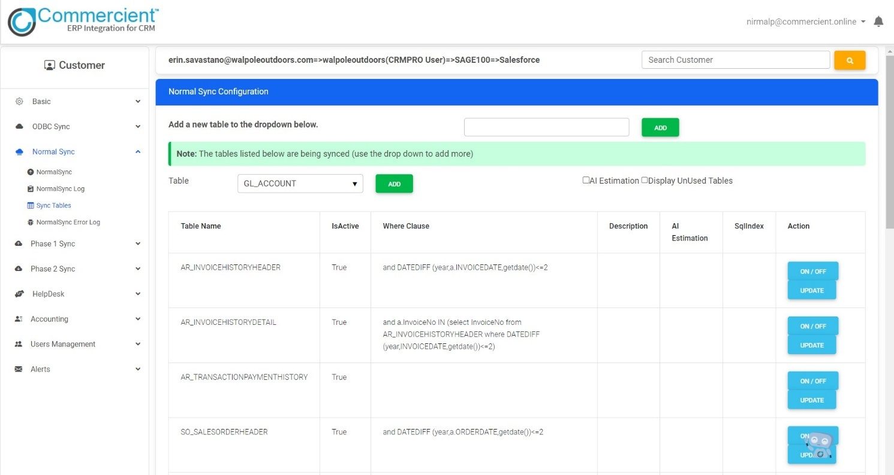

**4.2.9 Normal SYNC Error Logs**

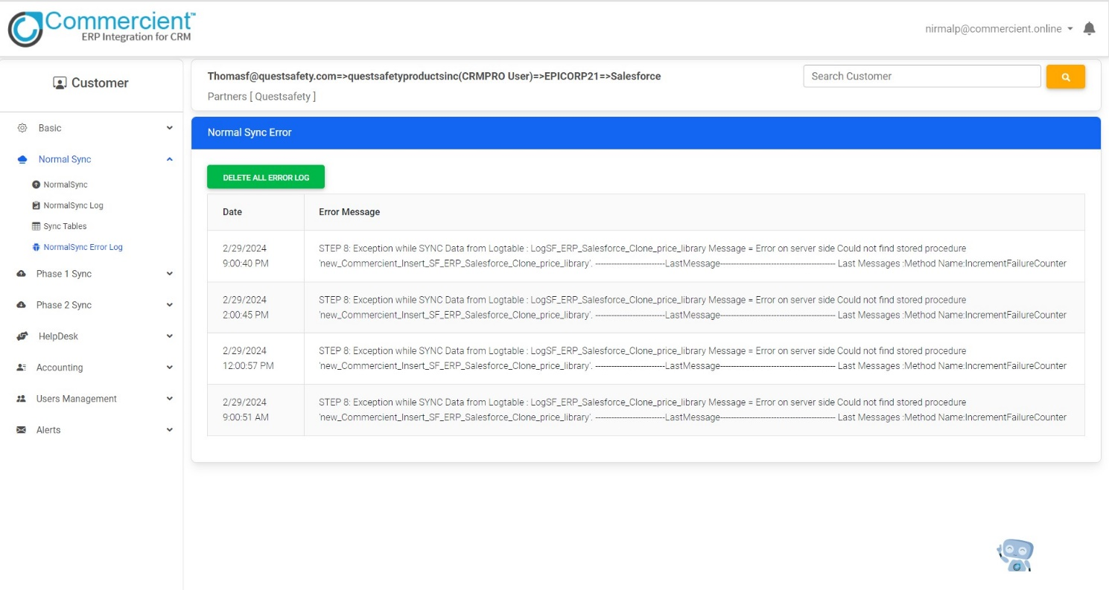

**4.2.10 Notes**

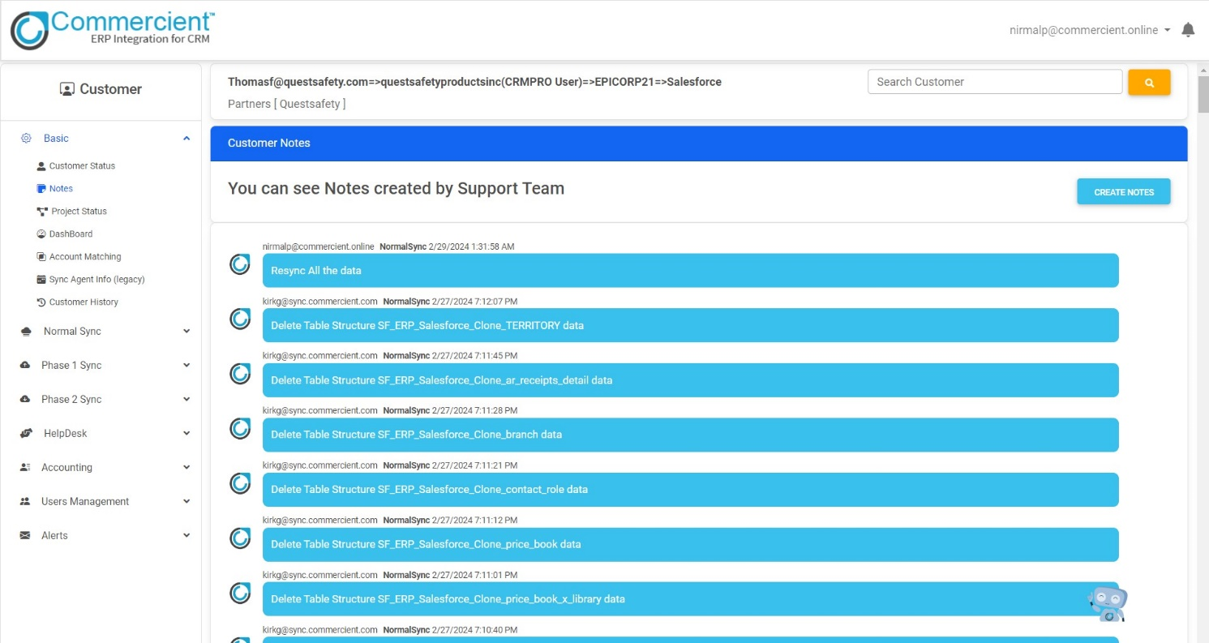

**4.2.11 Sync Dashboard**

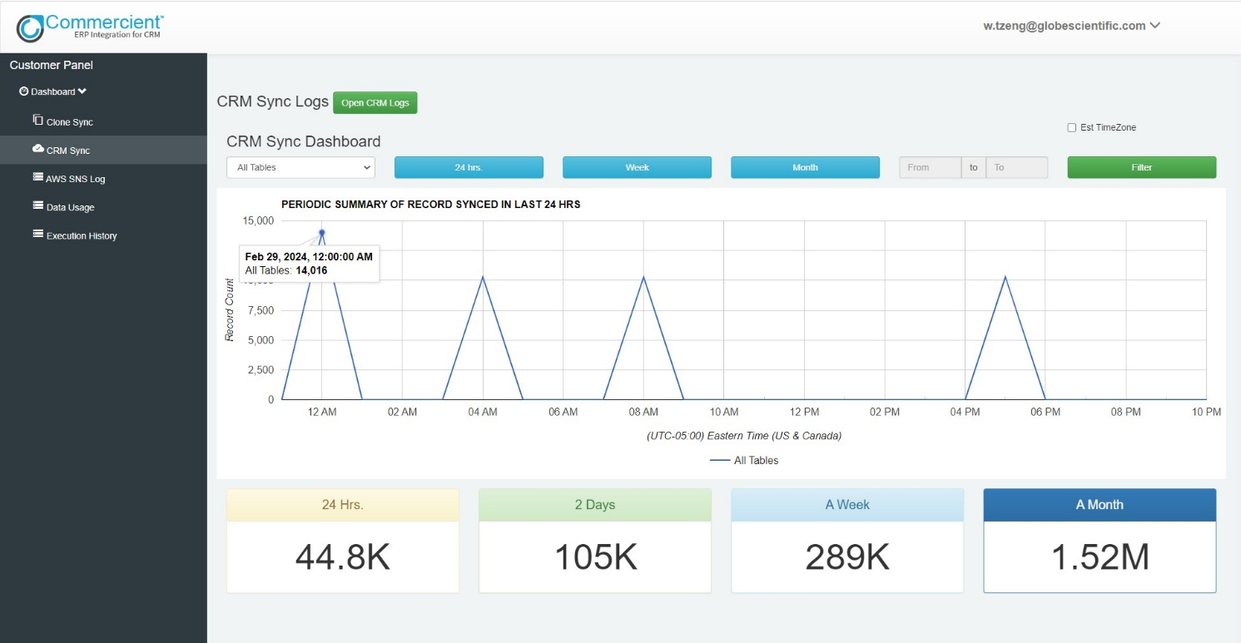

**4.2.12 Password Retrieval**

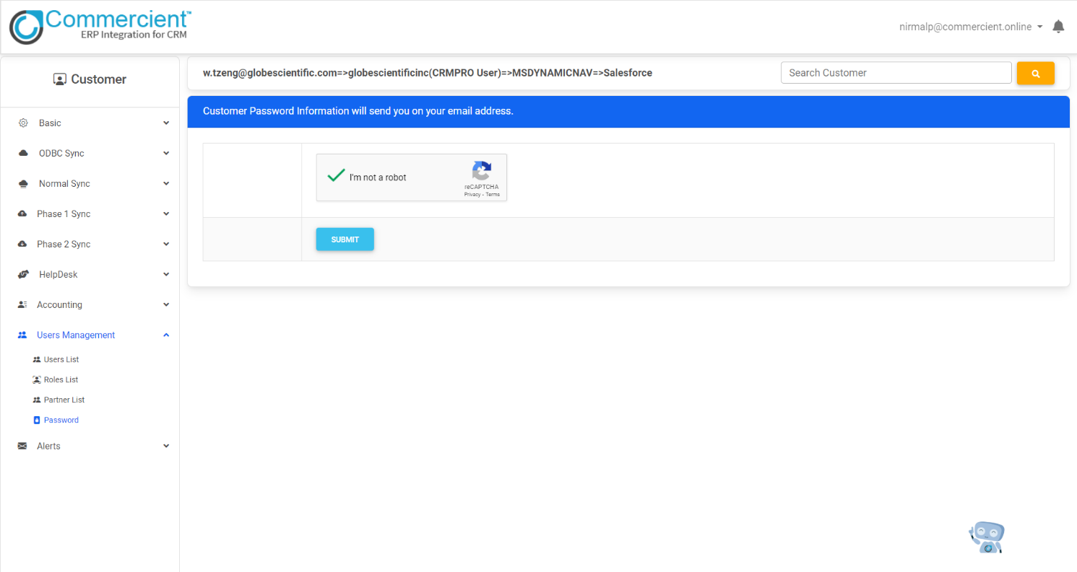

**4.2.13 Password Encrypt-Decrypt Formatter**

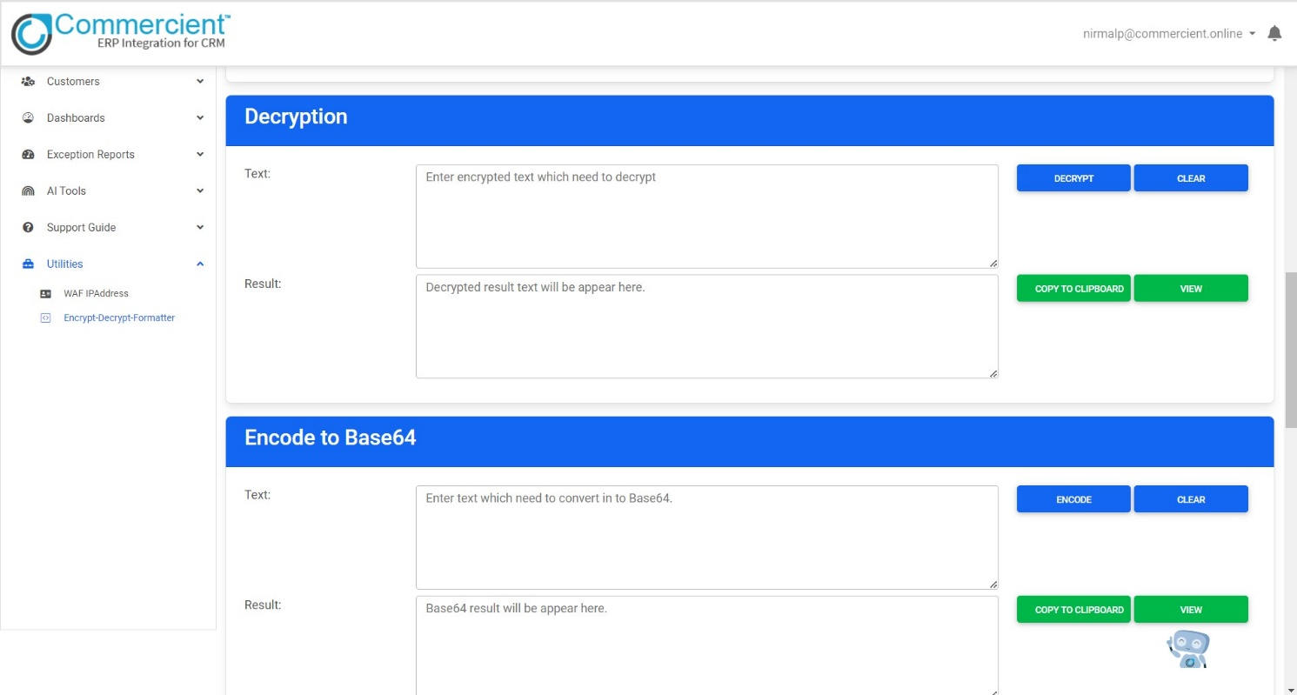

**4.2.14 AWS S3 Bucket Logs**

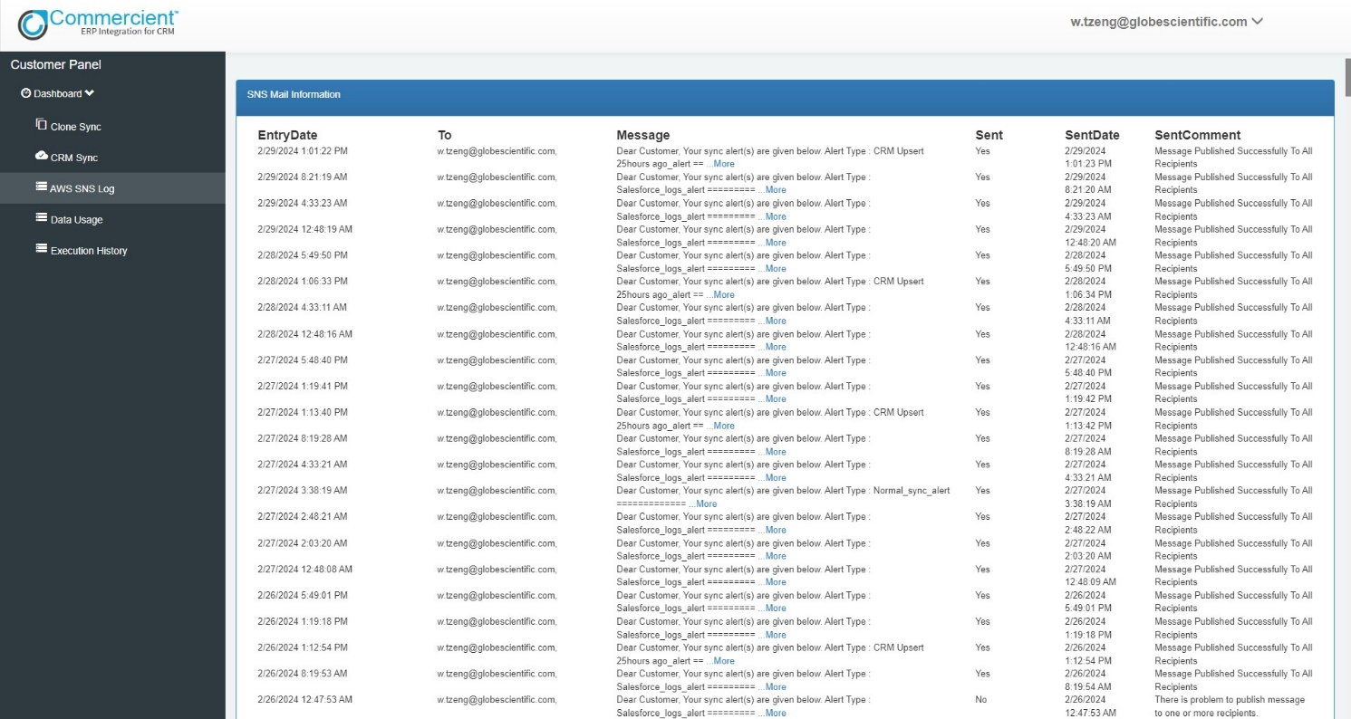

**4.2.15 Data Usage**

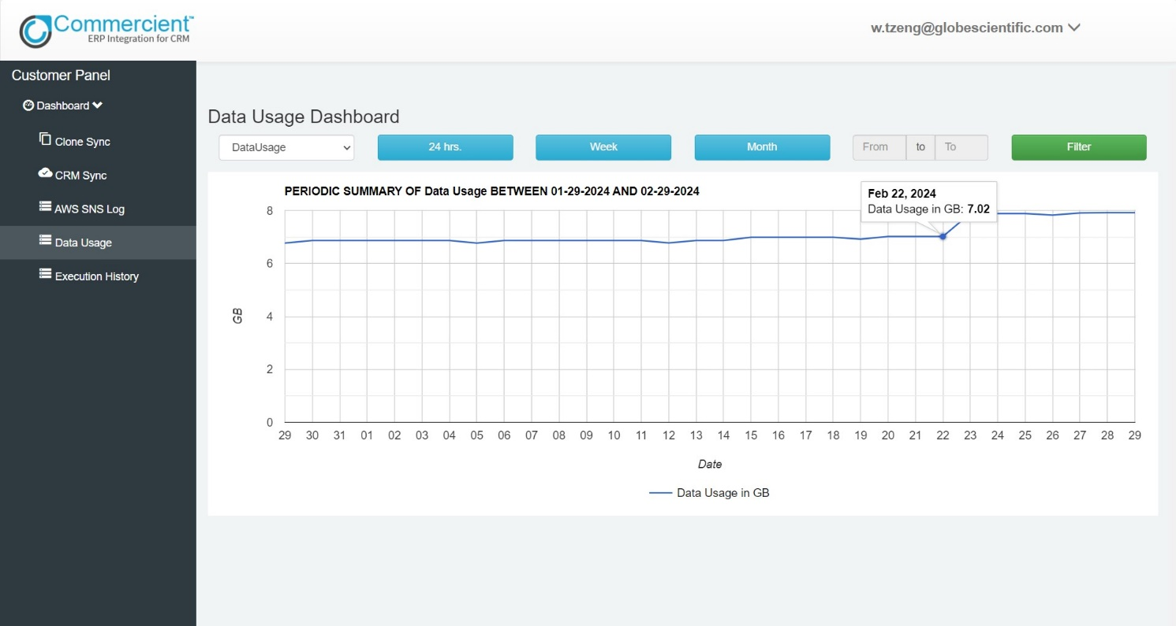

**4.2.16 Execution History**

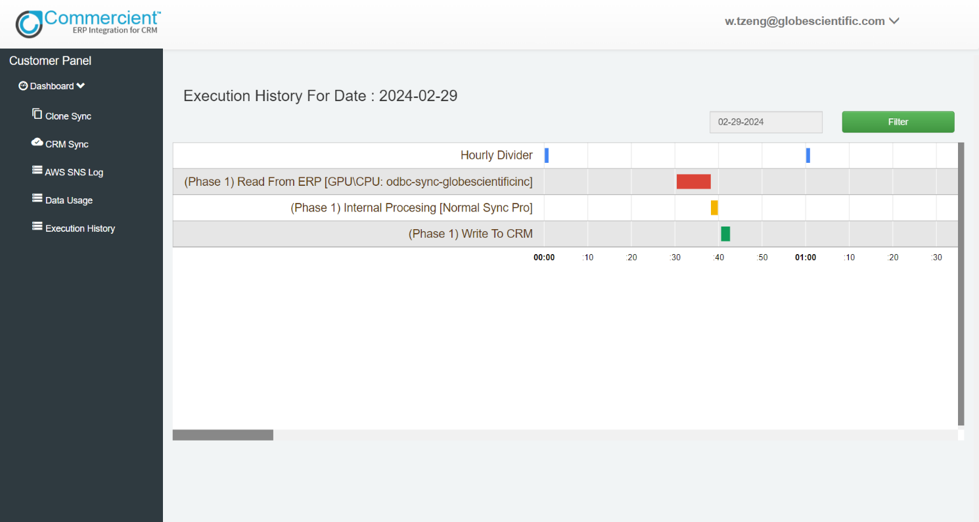

1. **Agile Documentation**
   1. **Agile Project Charter**

|  |  |  |  |  |
| --- | --- | --- | --- | --- |
| **Charter Element** | **Focus** | | | |
| **Project Name** | Commercient SYNC | | | |
| **Start Date** | 1st Jan 2024 | **Completion Date** | | 30th April 2024 |
| **Team Members** | | | | |
| **Name** | | | **Role** | |
| Nirmal Prajapati | | | Backend Developer [.NET] | |
| **Objectives** | The system aims to synchronize data seamlessly between the CRM (Customer Relationship Management) and ERP (Enterprise Resource Planning) platforms. This includes customer information, sales orders, invoices, inventory data, and other relevant records. | | | |
| The system seeks to establish a centralized database that consolidates information from both CRM and ERP systems. This database should provide a comprehensive view of customer interactions, transactions, and business operations. | | | |
| The objective is to streamline business processes by automating data transfer and eliminating manual entry tasks. This ensures efficiency, reduces errors, and enhances productivity across departments. | | | |
| The system aims to provide real-time updates and synchronization between the CRM and ERP systems. This ensures that all stakeholders have access to the most current and accurate information for informed decision-making. | | | |
| The system should offer customizable integration options to accommodate the unique requirements and configurations of different CRM and ERP platforms. This flexibility allows for seamless integration with various systems and workflows. | | | |
| The objective is to leverage integrated data for advanced reporting and analytics capabilities. This includes generating insights into customer behaviour, sales performance, inventory management, and other key metrics to drive strategic decisions. | | | |
| The system aims to enhance customer service by providing a unified view of customer interactions and transactions. This enables personalized communication, efficient issue resolution, and proactive customer engagement. | | | |

**5.2 Agile Roadmap / Schedule**

|  |  |
| --- | --- |
| **1st Quarter** | **2nd Quarter** |
| 1st Jan, 2024 to 31st Jan, 2024 | 1st Feb, 2024 to 15th Feb, 2024 |
| Understand project definition, gather requirements, finalized the project scope, Target User, and Core Component, and learn .NET Framework. | Design the system and draw various diagrams such as:   * Use case Diagram * Activity Diagram * Interaction Diagram   For system and prepare the database design |
| **3rd Quarter** | **4th Quarter** |
| 16th Feb, 2024 to 31th March, 2024 | 1st April, 2024 to 30th April, 2024 |
| Understand the Commercient SYNC Flow, in depth learning of Normal SYNC Project, Check Normal SYNC Error Logs of live Customers, Code Improvements. | Work on the XSLT to CSV, Batch Processing, Make Stored Procedures for backend, Automate System using AI. |
| **Final Quarter** | |
| 1st May, 2024 to 6th May, 2024 | |
| Final presentation and final documentation to be done. | |

**5.3 Agile Project Plan**

|  |  |  |
| --- | --- | --- |
| **Project Name** | **Start Date** | **End Date** |
| **Commercient SYNC** | **01/01/2024** | **30/04/2024** |

|  |  |  |  |  |  |
| --- | --- | --- | --- | --- | --- |
| **No.** | **TASK NAME** | **START** | **FINISH** | **DURATION**  **(DAYS)** | **STATUS** |
| **1** | **Sprint 1** | **01 Jan 2024** | **31 Jan 2024** | **31** | **Complete** |
| Learn about C# | 01 Jan 2024 | 15 Jan 2024 | 15 | Complete |
| Demo Project in C# | 16 Jan 2024 | 17 Jan 2024 | 2 | Complete |
| Learn about SQL | 18 Jan 2024 | 22 Jan 2024 | 5 | Complete |
| Demo Project using SQL | 23 Jan 2024 | 24 Jan 2024 | 2 | Complete |
| Learn about WCF API & WEB API & REST API | 25 Jan 2024 | 26 Jan 2024 | 1 | Complete |
| Learn about Salesforce | 26 Jan 2024 | 27 Jan 2024 | 2 | Complete |
| Demo Project for Sending data from SQL to Salesforce, Zoho and HubSpot. | 28 Jan 2024 | 31 Jan 2024 | 4 | Complete |
| **2** | **Sprint 2** | **01 Feb 2024** | **15 Feb 2024** | **15** | **Complete** |
| Use Case Diagram | 01 Feb 2024 | 02 Feb 2024 | 2 | Complete |
| Activity Diagram | 03 Feb 2024 | 04 Feb 2024 | 2 | Complete |
| Interaction Diagram | 05 Feb 2024 | 06 Feb 2024 | 2 | Complete |
| Database Design | 07 Feb 2024 | 10 Feb 2024 | 4 | Complete |
| System Flow | 11 Feb 2024 | 15 Feb 2024 | 5 | Complete |
| **3** | **Sprint 3** | **16 Feb 2024** | **31 Mar 2024** | **44** | **Complete** |
| Understand the Commercient SYNC Flow | 16 Feb 2024 | 20 Feb 2024 | 5 | Complete |
| Learn about Normal SYNC Flow | 21 Feb 2024 | 28 Feb 2024 | 8 | Complete |
| Check Normal SYNC Error Logs for Live Customers | 01 Mar 2024 | 03 Mar 2024 | 3 | Complete |
| Code Improvements in Normal SYNC Project | 04 Mar 2024 | 12 Mar 2024 | 9 | Complete |
| Changes in Stored Procedures in SQL | 13 Mar 2024 | 14 Mar 2024 | 1 | Complete |
| Shopify Page Design | 15 Mar 2024 | 16 Mar 2024 | 2 | Complete |
| Understand the ODBC SYNC Flow | 17 Mar 2024 | 20 Mar 2024 | 4 | Complete |
| Make a new architecture for SYNC | 21 Mar 2024 | 22 Mar 2024 | 2 | Complete |
| XML to CSV using XSLT File Format | 23 Mar 2024 | 24 Mar 2024 | 2 | Complete |
| Change the View in SQL | 24 Mar 2024 | 26 Mar 2024 | 3 | Complete |
| Batch Processing for Send data from Customer Database to Commercient Server | 27 Mar 2024 | 29 Mar 2024 | 3 | Complete |
| Solve Normal SYNC Tickets | 30 Mar 2024 | 31 Mar 2024 | 2 | Complete |
| **4** | **Sprint 4** | **01 Apr 2024** | **30 Apr 2024** | **30** | **Complete** |
| To Learn about SQL | 01 Apr 2024 | 02 Apr 2024 | 2 | Complete |
| To Learn about Microsoft SQL Server | 03 Apr 2024 | 10 Apr 2024 | 8 | Complete |
| To Learn CRUD in ASP.NET MVC | 11 Apr 2024 | 14 Apr 2024 | 4 | Complete |
| To perform a database operation on Normal SYNC Project | 15 Apr 2024 | 18 Apr 2024 | 4 | Complete |
| To perform back-end operations on Normal SYNC Page for the admin side | 19 Apr 2024 | 21 Apr 2024 | 3 | Complete |
| To perform back-end operations on the Dashboard for the admin side | 22 Apr 2024 | 23 Apr 2024 | 2 | Complete |
| To perform back-end operations on Add SYNC page for the admin side | 24 Apr 2024 | 25 Apr 2024 | 2 | Complete |
| To perform back-end operations on Normal SYNC ReSYNC | 26 Apr 2024 | 27 Apr 2024 | 2 | Complete |
| To perform back-end operations on Manual Table ReSYNC | 28 Apr 2024 | 28 Apr 2024 | 1 | Complete |
| To perform back-end operations on Dynamic Query Enable | 29 Apr 2024 | 29 Apr 2024 | 1 | Complete |
| To perform back-end operations to Clean Clone Tables | 30 Apr 2024 | 30 Apr 2024 | 1 | Complete |
| **5** | **Sprint 5** | **01 May 2024** | **06 May 2024** | **6** | **Complete** |
| Testing | 01 May 2024 | 04 May 2024 | 4 | Complete |
| Documentation | 05 May 2024 | 06 May 2024 | 2 | Complete |

**5.4 Agile User Story**

* A user story is a tool used in agile software development to capture a description of a software feature from an end-user perspective. A user story describes the type of user, what they want, and why. A user story helps to create a simplified description of a requirement for the system.
* A story point is a metric used in agile project management and development to estimate the difficulty of implementing a given user story.

|  |  |  |  |  |
| --- | --- | --- | --- | --- |
| **Story ID** | **PRIORITY** | **AS A** | **I WANT TO** | **SO THAT I CAN** |
| 1 | High | User | Easily synchronize customer data between CRM and ERP | Ensure consistency and accuracy in customer records |
| 2 | High | User | Access comprehensive reports combining CRM and ERP data | Analyse business performance and make informed decisions |
| 3 | Mid | User | Save frequently accessed CRM and ERP records for quick reference | Efficiently access and review important information |
| 4 | Mid | User | Compare CRM and ERP data across different time periods or segments | Identify trends and patterns for strategic planning |
| 5 | Mid | User | Apply filters to customize views of integrated CRM and ERP data | Focus on specific information relevant to my tasks |
| 6 | High | Admin | Configure integration settings between CRM and ERP systems | Ensure seamless and accurate data synchronization |
| 7 | High | Admin | Monitor integration logs and troubleshoot synchronization issues | Control access to sensitive information and features |
| 8 | Mid | Admin | Manage permissions for users accessing integrated CRM and ERP data | I can facilitate communication between potential buyers or renters and property owners or agents. |

**5.5 Agile Release Plan**

|  |  |  |  |  |  |
| --- | --- | --- | --- | --- | --- |
| **No.** | **TASK NAME** | **START** | **RELEASE DATE** | **DURATION**  **(DAYS)** | **STATUS** |
| **1** | **Sprint 1** | | | | |
| Learn about C# | 01 Jan 2024 | 15 Jan 2024 | 15 | Released |
| Demo Project in C# | 16 Jan 2024 | 17 Jan 2024 | 2 | Released |
| Learn about SQL | 18 Jan 2024 | 22 Jan 2024 | 5 | Released |
| Demo Project using SQL | 23 Jan 2024 | 24 Jan 2024 | 2 | Released |
| Learn about WCF API & WEB API & REST API | 25 Jan 2024 | 26 Jan 2024 | 1 | Released |
| Learn about Salesforce | 26 Jan 2024 | 27 Jan 2024 | 2 | Released |
| Demo Project for Sending data from SQL to Salesforce, Zoho and Hubspot. | 28 Jan 2024 | 31 Jan 2024 | 4 | Released |
| **2** | **Sprint 2** | | | | |
| Use Case Diagram | 01 Feb 2024 | 02 Feb 2024 | 2 | Released |
| Activity Diagram | 03 Feb 2024 | 04 Feb 2024 | 2 | Released |
| Interaction Diagram | 05 Feb 2024 | 06 Feb 2024 | 2 | Released |
| Database Design | 07 Feb 2024 | 10 Feb 2024 | 4 | Released |
| System Flow | 11 Feb 2024 | 15 Feb 2024 | 5 | Released |
| **3** | **Sprint 3** | | | | |
| Understand the Commercient SYNC Flow | 16 Feb 2024 | 20 Feb 2024 | 5 | Released |
| Learn about Normal SYNC Flow | 21 Feb 2024 | 28 Feb 2024 | 8 | Released |
| Check Normal SYNC Error Logs for Live Customers | 01 Mar 2024 | 03 Mar 2024 | 3 | Released |
| Code Improvements in Normal SYNC Project | 04 Mar 2024 | 12 Mar 2024 | 9 | Released |
| Changes in Stored Procedures in SQL | 13 Mar 2024 | 14 Mar 2024 | 1 | Released |
| Shopify Page Design | 15 Mar 2024 | 16 Mar 2024 | 2 | Released |
| Understand the ODBC SYNC Flow | 17 Mar 2024 | 20 Mar 2024 | 4 | Released |
| Make a new architecture for SYNC | 21 Mar 2024 | 22 Mar 2024 | 2 | Released |
| XML to CSV using XSLT File Format | 23 Mar 2024 | 24 Mar 2024 | 2 | Released |
| Change the View in SQL | 24 Mar 2024 | 26 Mar 2024 | 3 | Released |
| Batch Processing for Send data from Customer Database to Commercient Server | 27 Mar 2024 | 29 Mar 2024 | 3 | Released |
| Solve Normal SYNC Tickets | 30 Mar 2024 | 31 Mar 2024 | 2 | Released |
|  | **Sprint 4** | | | | |
| To Learn about SQL | 01 Apr 2024 | 02 Apr 2024 | 2 | Released |
| To Learn about Microsoft SQL Server | 03 Apr 2024 | 10 Apr 2024 | 8 | Released |
| To Learn CRUD in ASP.NET MVC | 11 Apr 2024 | 14 Apr 2024 | 4 | Released |
| To perform a database operation on Normal SYNC Project | 15 Apr 2024 | 18 Apr 2024 | 4 | Released |
| To perform back-end operations on Normal SYNC Page for the admin side | 19 Apr 2024 | 21 Apr 2024 | 3 | Released |
| To perform back-end operations on the Dashboard for the admin side | 22 Apr 2024 | 23 Apr 2024 | 2 | Released |
| To perform back-end operations on Add SYNC page for the admin side | 24 Apr 2024 | 25 Apr 2024 | 2 | Released |
| To perform back-end operations on Normal SYNC ReSYNC | 26 Apr 2024 | 27 Apr 2024 | 2 | Released |
| To perform back-end operations on Manual Table ReSYNC | 28 Apr 2024 | 28 Apr 2024 | 1 | Released |
| To perform back-end operations on Dynamic Query Enable | 29 Apr 2024 | 29 Apr 2024 | 1 | Released |
| To perform back-end operations to Clean Clone Tables | 30 Apr 2024 | 30 Apr 2024 | 1 | Released |
| **5** | **Sprint 5** | | | | |
| Testing | 01 May 2024 | 04 May 2024 | 4 | Released |
| Documentation | 05 May 2024 | 06 May 2024 | 2 | Released |

**5.6 Agile Sprint Backlog**

|  |  |  |  |
| --- | --- | --- | --- |
| **TASK NAME**  **[BACKLOG]** | **STATUS** | **ESTIMATED HOURS** | **ACTUAL**  **HOURS** |
| **User Story (For Frontend User)** | | | |
| Set Template (User) | Completed | 10 | 10 |
| Home Page (User) | Completed | 7 | 7 |
| CRM-ERP Integration Dashboard (User) | Completed | 12 | 14 |
| View Integrated Data (User) | Completed | 10 | 8 |
| Saved Views Page (User) | Completed | 4 | 6 |
| Compare Data (User) | Completed | 5 | 7 |
| Synchronize Data Module (User) | Completed | 12 | 13 |
| Custom Data Filtering (User) | Completed | 8 | 9 |
| Landing Pages (User) | Completed | 1 | 1 |
| Login/Registration Page (User) | Completed | 3 | 3 |
| **TOTAL** | | **72** | **78** |
| **User Story (For Admin)** | | | |
| Set Template (Admin) | Completed | 2 | 2 |
| Dashboard page (Admin) | Completed | 2 | 2 |
| Configure Integration Settings (Admin) | Completed | 5 | 6 |
| Manage User Access (Admin) | Completed | 4 | 5 |
| Monitor Synchronization Logs (Admin) | Completed | 4 | 5 |
| Troubleshoot Integration Issues (Admin) | Completed | 1 | 2 |
| Generate Reports (Admin) | Completed | 7 | 7 |
| Login Page (Admin) | Completed | 3 | 3 |
| **TOTAL** | | **28** | **32** |

**5.7 Agile Test Plan**

|  |  |  |  |  |
| --- | --- | --- | --- | --- |
| **No.** | **Description** | **Data** | **Expected System Response** | **Result** |
| 1 | User Registration | Valid user registration data | Allow users to create an account | Pass |
| 2 | User Login | Valid login credentials | Grant access to the system to submit property or Add Favourite and Compare | Pass |
| 3 | User Login | Invalid login credentials | Display error message and deny access | Pass |
| 4 | CRM-ERP Data Search | Search criteria (e.g., customer name) | Display matching the search criteria | Pass |
| 5 | ERP to CRM Data SYNC | Table ID  (e.g., Login Required) | Table with proper prefix | Pass |
| 6 | View SYNC Data | Customer ID  (e.g., Login Required) | Display detailed information about the sync | Pass |
| 7 | Customer Registration | Valid Customer Data | Allow Customers to create an account | Pass |
| 8 | Helpdesk | Customer ID  (e.g., Login Required) | Creates ticket for Support | Pass |
| 9 | View Customer Details | Customer ID  (e.g., Login Required) | Display detailed information about the property | Pass |
| 10 | ReSYNC Data | Table Required | Table should be available at Customer Side | Pass |
| 11 | Manual SYNC | Commercient Flag Enable | Flag value change and Manual SYNC Data | Pass |
| 12 | Dynamic Query | Commercient Flag Enable | Flag value change and Enable Dynamic Query | Pass |
| 13 | Send Data | API Authentication Required | Send Data from Database to Commercient Server | Pass |
| 14 | Batch Processing | Commercient Flag Enable | Send the data in Partition of 200 | Pass |
| 15 | Admin Login | Invalid admin login credentials | Display error message and deny access | Pass |
| 16 | Admin Dashboard | - | Display an overview of system statistics and functionalities | Pass |

1. **Proposed Enhancement**

Proposed enhancements for SYNC tool include implementing AI-powered data analytics to offer users actionable insights derived from integrated data, integrating natural language processing for intuitive communication, automating data entry and validation processes using AI algorithms to ensure accuracy, delivering personalized recommendations based on user interactions, enabling sentiment analysis for customer feedback to drive proactive actions, and implementing intelligent process automation to streamline workflows and improve operational efficiency. These enhancements aim to elevate user experience, optimize decision-making, and enhance overall system performance.

1. **Conclusion**

In conclusion, the CRM and ERP integration tool offers streamlined operations, informed decision-making, and enhanced customer engagement. By combining CRM and ERP functionalities seamlessly, it provides organizations with a comprehensive solution to optimize processes and stay competitive in the market.

1. **Bibliography**

* [**https://dotnet.microsoft.com/en-us/learn/dotnet/**](https://dotnet.microsoft.com/en-us/learn/dotnet/)
* [**https://developer.salesforce.com/docs**](https://developer.salesforce.com/docs)
* [**https://www.zoho.com/crm/help/**](https://www.zoho.com/crm/help/)
* [**https://learn.microsoft.com/en-us/sql/?view=sql-server-ver16**](https://learn.microsoft.com/en-us/sql/?view=sql-server-ver16)
* [**https://www.hubspot.com/products/crm**](https://www.hubspot.com/products/crm)
* [**https://www.sap.com/india/products/erp/what-is-sap-erp.html**](https://www.sap.com/india/products/erp/what-is-sap-erp.html)
* [**https://www.youtube.com/channel/UC92x63Cete3v0erwL3JOJEA**](https://www.youtube.com/channel/UC92x63Cete3v0erwL3JOJEA)